# Future Transportation Prospect : The V2V Technology

United State officials are close to approving new requirements for enabling vehicles to communicate with each other. Officials hope the new technology will reduce the number of traffic accidents. Automobile manufactures may be required to equip all new cars with what are being called 'vehicle-to-vehicle' communication devices within the next 3 years.

## What is V2V?

Vehicle-to-vehicle, or V2V, is a communication technology. It enables vehicles to share information about their speed and movement at a rate of 10 times a second. Cars will be able to identify possible dangers within about 300 meters. The cars will then warn their drivers or even take action to avoid in accident.

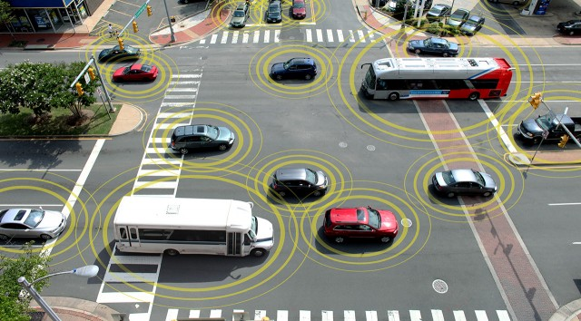

IMAGE: The feds want to make V2V technology a requirement on all new cars.

The drivers will be able to see, hear and even feel the warning signals through shaking of the seat. The U.S. National Highway Traffic Safety Administration expects the new system to reduce the number of car accidents by as much as 80 percent.

Research

Auto makers and researchers have been working for years to develop crash-avoidance systems based on vehicle-to-vehicle communications. Such systems eventually could work in collaboration with technology designed to automate various driving tasks, including braking and steering.

Difficult

The hardware and software for vehicle-to-vehicle communications is nearly ready for mass deployment. But auto makers have other hurdles to overcome, including establishing a big enough network of equipped vehicles for the system to work.

Critics admit that V2V technology is a major development, but they are concerned about possible conflicts with other wireless devices. They say those devices already operate in the wireless frequencies planned for V2V technology.

Greg Winfree is with the U.S. Department of Transportation. He says the new technology will change the way people deal with traffic accidents.

"The way to look at it is the first 50 years of transportation safety were focused on surviving crashes. We see the future as technology that avoids crashes overall," said Winfree.

"If somehow we are sharing this spectrum and there's interference and so a car that could have, we could have prevented the crash, we are not able to prevent the crash because someone else is using the spectrum," said Belcher.

Scott Belcher says people may also be concerned about their privacy. He worries about the possibility of using V2V technology to follow individual drivers and document their driving habits. Government agencies and private industry have already invested almost $1 billion in research.

U.S. officials expect the new technology will be required in American vehicles by early 2017. They believe it is the first step toward a better and safer transportation system.